How to Access the Google earth cache from SasPlanet

- You should of course access the area you want to create a map from using Google Earth Pro, then terminate it.

- You should be at the latest level of SasPlanet. You can download my version from here:
http://gdayii.ca/Downloads/Sasplanet.zip
After downloading unzip to a directory eg: C:\xxx then do the following:
- Open a File explorer and go to the directory where you unzipped the above file and open the first directory called SasPlanet_GDAYII. There you will find another directory called SasPlanet.
- Cut this SasPlanet directory and Paste it into root C: so that now you have a C:\SasPlanet.
- Create a shortcut to the C:\SasPlanet\SasPlanet.exe and start SasPlanet.
- Start Sat2Chart and open the SasPlanet option tab.
- Change the "SasPlanet Location:" field to C:\SasPlanet

- Download the following two zip files, unzip them and copy the contents into your SasPlanet directory:
- http://gdayii.ca/Downloads/TileStorage_GC_1.0.0.8.7z
- http://gdayii.ca/Downloads/TileStorage_GE_1.0.0.9.7z
You should now have in your SasPlanet directory:
TileStorage_GC.dll and TileStorage_GE.dll

- Also download this zmp file:
- http://gdayii.ca/Downloads/GeoCacherDirect.zmp
If it doesn’t already exist copy it into :C:\SasPlanet\Maps\sas.maps\
I didn’t need to install this file there was one already.

- Restart SasPlanet then open the the Settings/Options/Cache tab in the “GoogleEarth cache folder “ enter:
- C:\Users\phigg\AppData\LocalLow\Google\GoogleEarth\
Change the “phigg” to your user id.

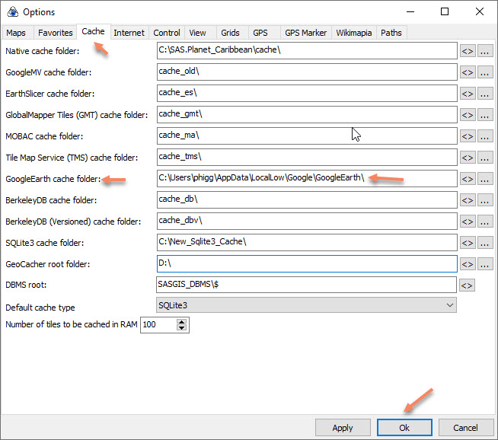

Press OK.

- Open the Maps and select GoogleEarth/Earth (GoogleEarth)
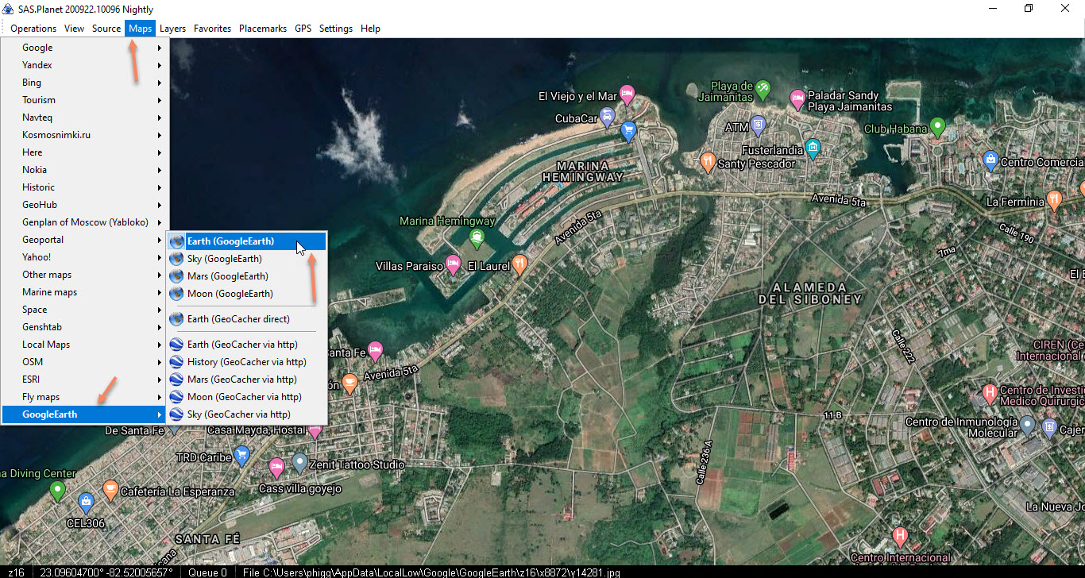
- If you have accessed the Google Earth history, you can access them by right clicking on the Map and selecting version:
